Experiment 1

Program

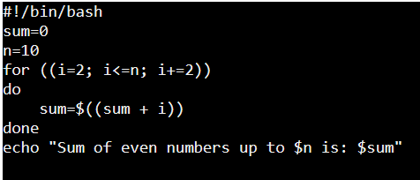

Output:



Experiment 2:

Output:



Experiment 3:

Output:

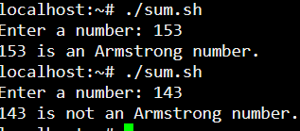

Experiment 4:

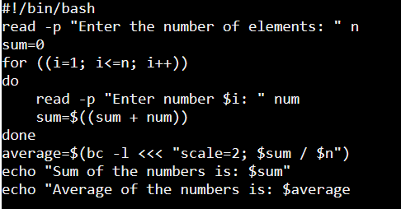

Output:

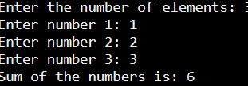

Experiment 5:

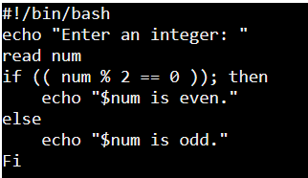

Output:



Experiment 6:

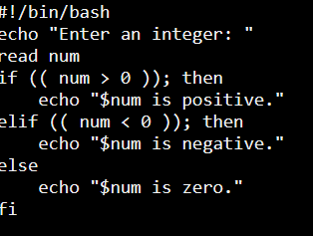

Output:

Experiment 7:

Output:

Experiment 8:

Output:

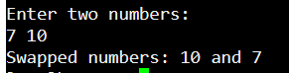

Experiment 9:

Output:

Experiment 10 :